Cannatwin Backend:

1.Required getapi which includes query params toDate and fromDate fro Dashboard screen.  
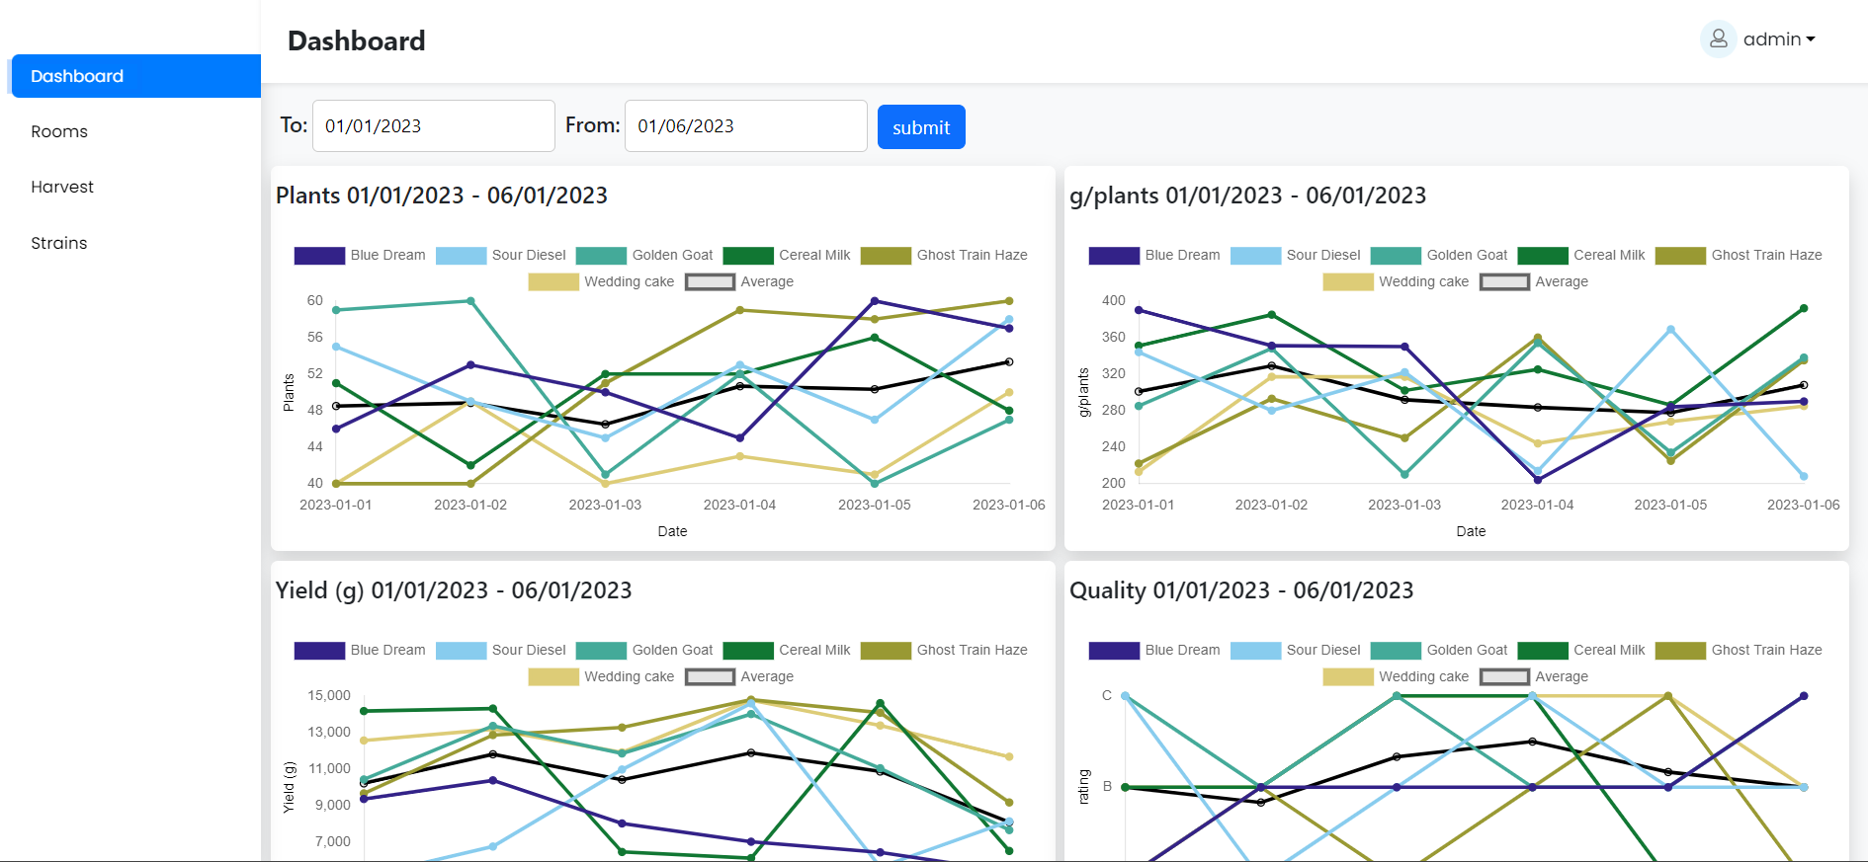

2.Required Get Api For Rooms screen which include query params

a.facilities b.room c.toDate d. fromDate

and also use required post api into upload data.

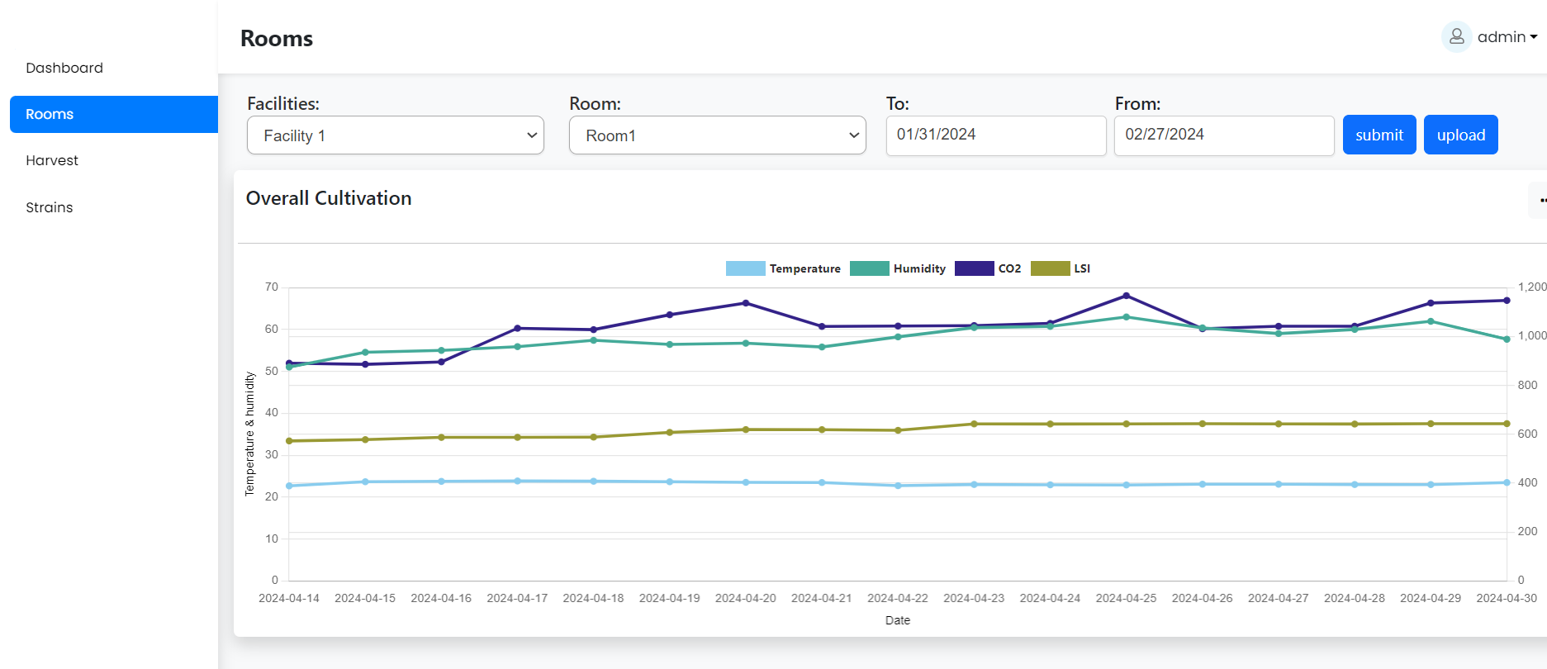

3.Require Get api for harvest batches

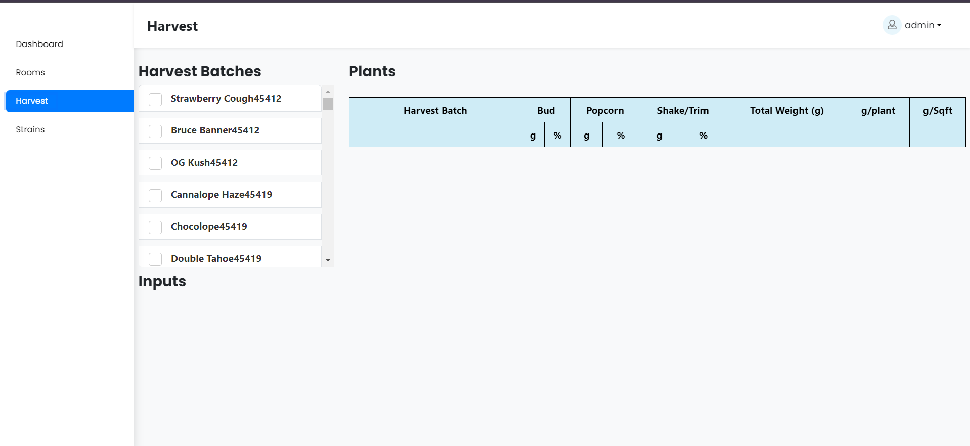

4.Required login and register api’s for cannatwin.

5.Required getUserDetails api which includes below fields also require user details update api.  
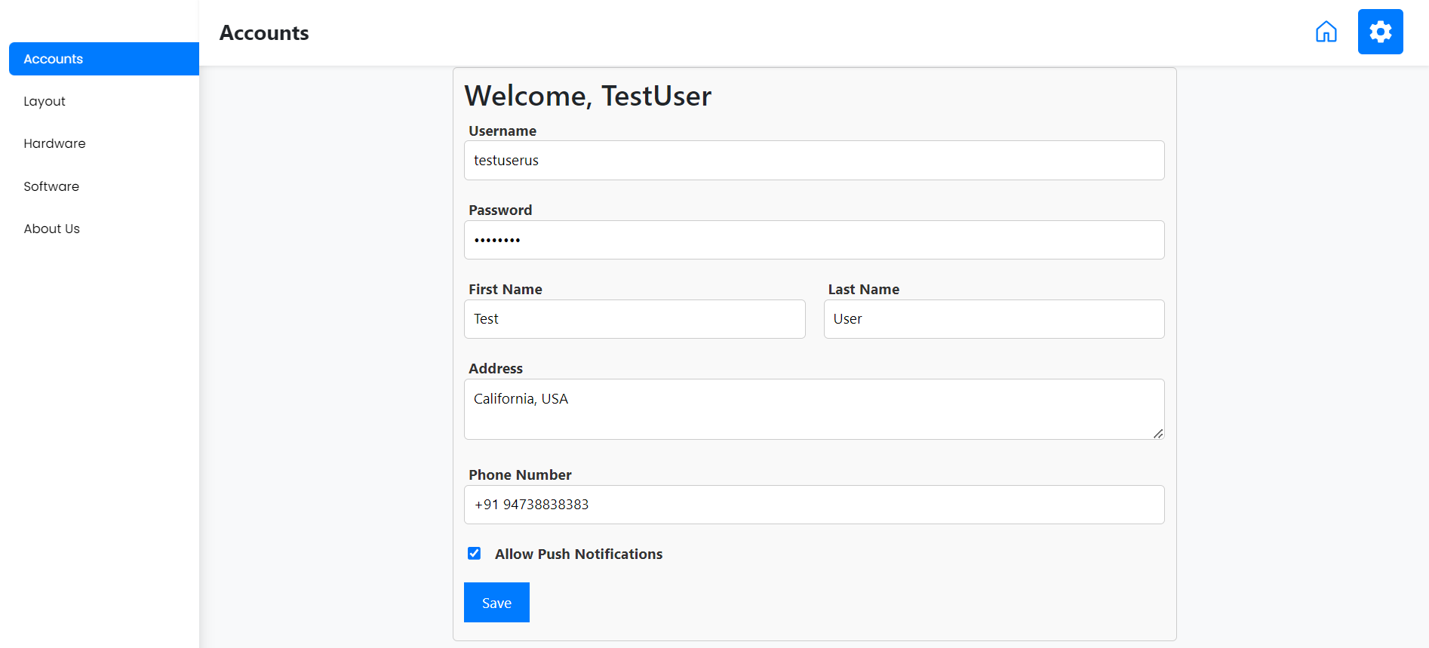

6.Required CRUD operations for layout section verify in ([https://cannatwin.com/layout)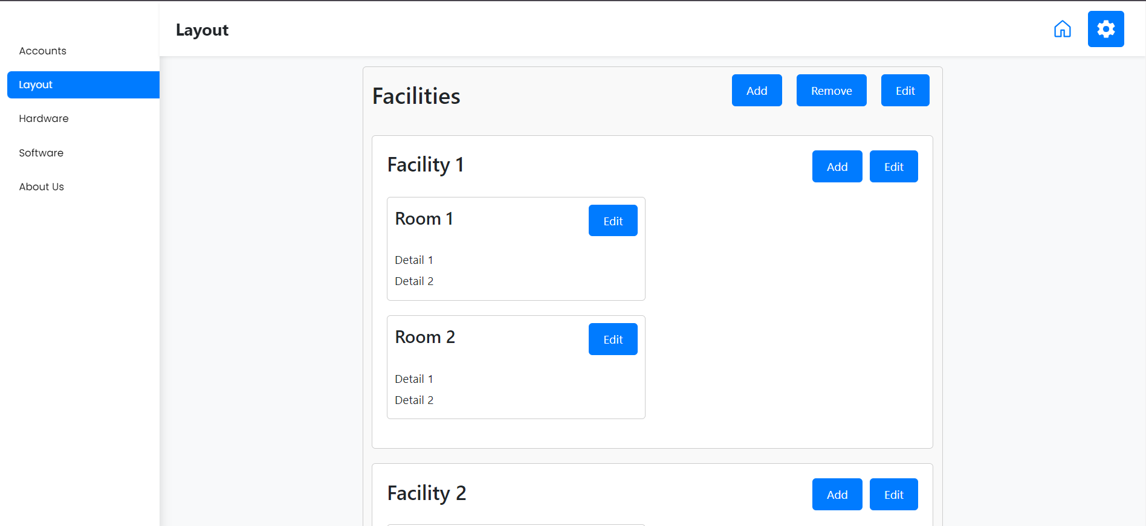](https://cannatwin.com/layout))

7.Required CRUD Operation for Hardware Verify in([https://cannatwin.com/hardware)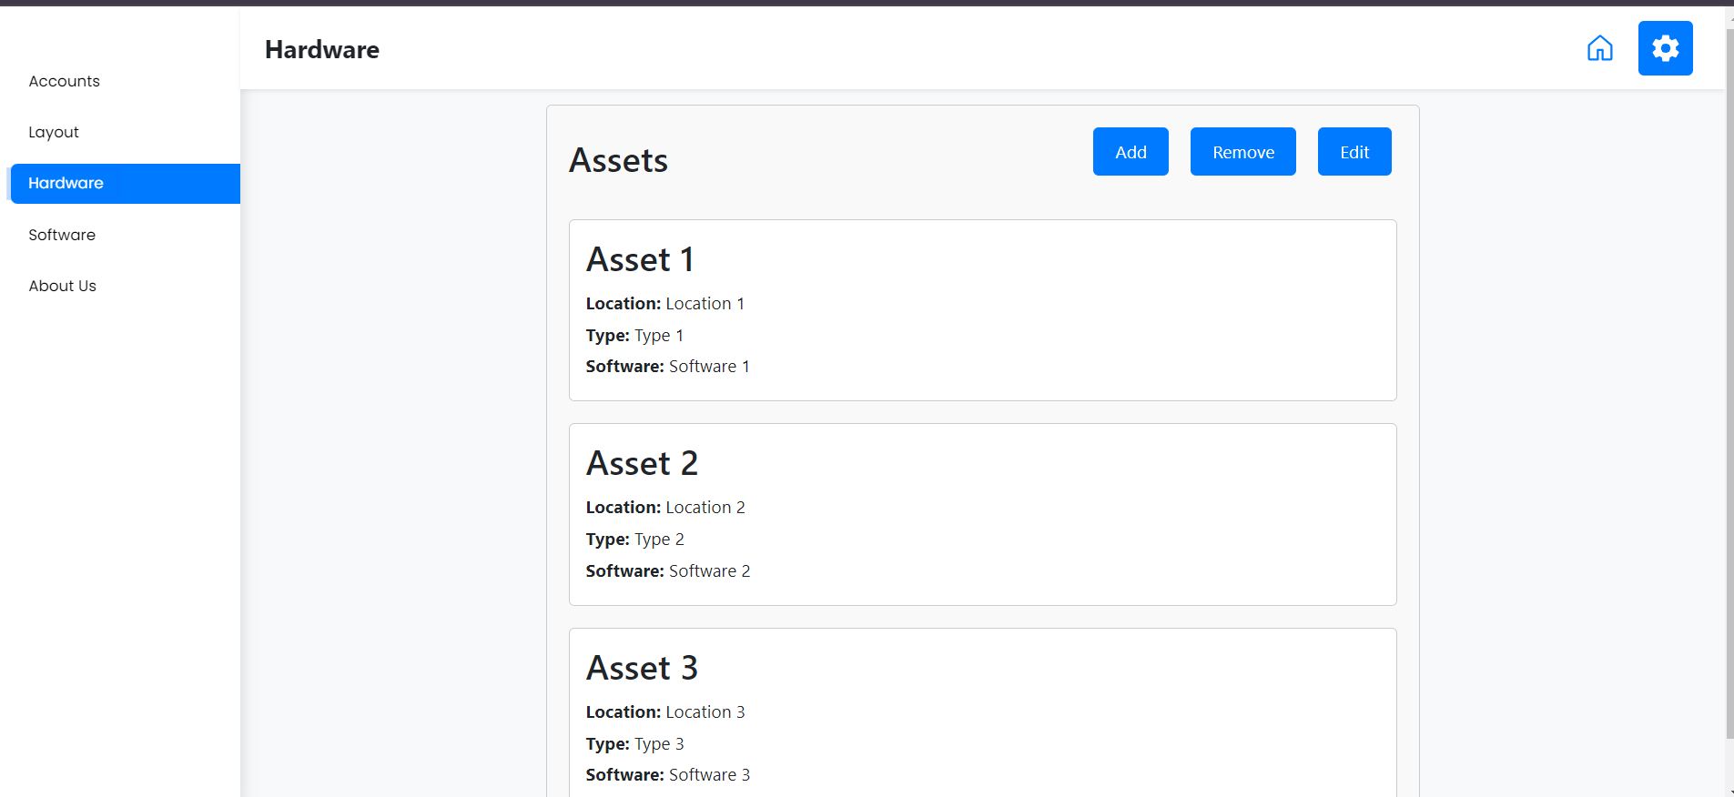](https://cannatwin.com/hardware))

8.Required CRUD Apis for software section to handle api integration dynamically verify in(https://cannatwin.com/software)  
